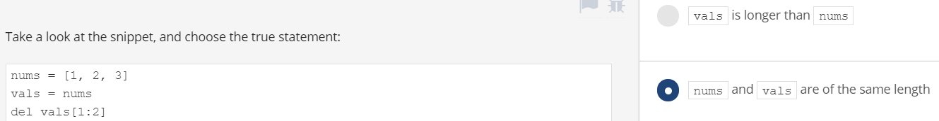

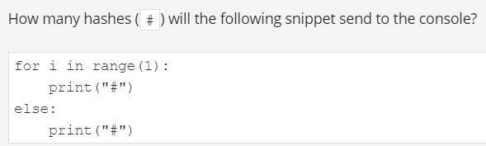

Two

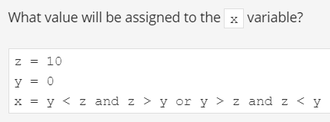

True

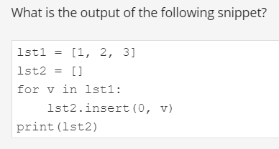

[3, 2, 1]

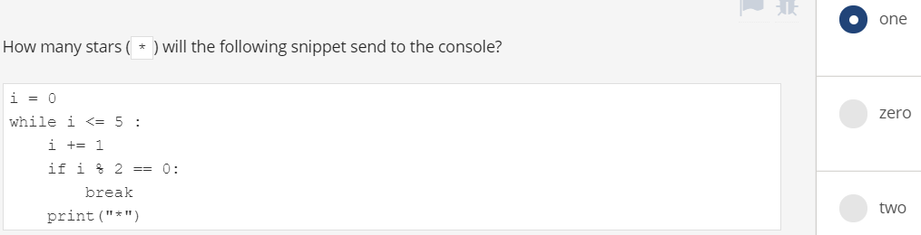

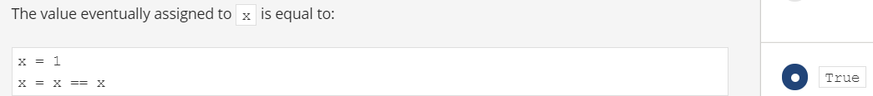

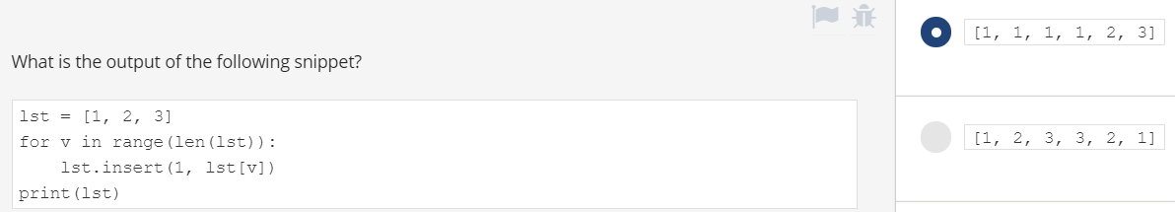

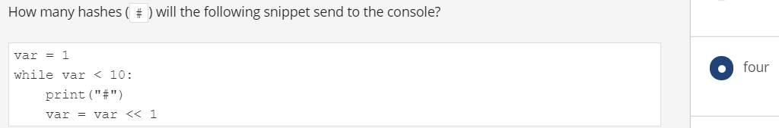

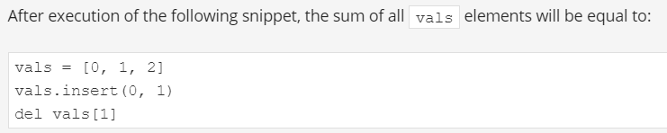

Sum of elements = 4



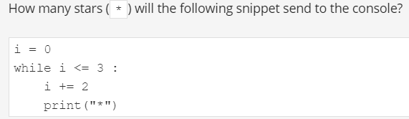

Two

